QUESTION 2

Smart Public Health Monitoring Optimization Using Data Analysis and Dynamic Programming

Aim
To analyze disease spread using data analytics and optimize prediction using Dynamic Programming for effective public health monitoring.

Theory
Public health monitoring helps in tracking disease spread and supporting healthcare planning. Data collected from hospitals and healthcare centers is analyzed to identify disease trends and predict future cases.
Dynamic Programming is an optimization technique that stores previously computed results and avoids repeated calculations. This improves efficiency and reduces processing time.

Objectives
- Monitor disease spread.
- Predict future disease trends.
- Improve healthcare decision-making.
- Support public health planning.
- Analyze large healthcare datasets.

Algorithm
Step 1: Input disease case data.
Step 2: Initialize Dynamic Programming array.
Step 3: Store the first disease case value.
Step 4: Calculate cumulative disease cases.
Step 5: Generate prediction results.
Step 6: Display output.

Source Code
n = int(input("Enter number of records: "))

cases = []

for i in range(n):
cases.append(int(input("Enter cases: ")))

dp = [0] * n
dp[0] = cases[0]

for i in range(1, n):
dp[i] = dp[i-1] + cases[i]

print("Disease Cases:", cases)
print("Predicted Total Cases =", dp[n-1])

Sample Input
Enter number of records: 5
Enter cases: 10
Enter cases: 15
Enter cases: 20
Enter cases: 25
Enter cases: 30

Sample Output
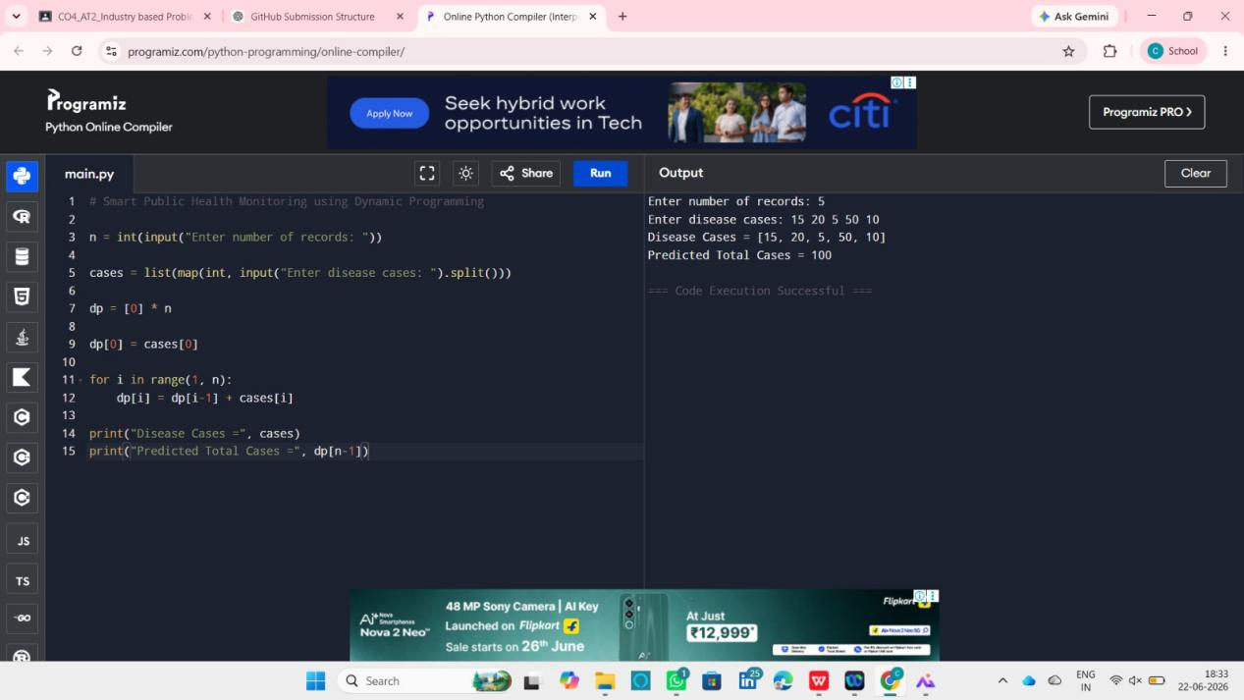

Working Example
Disease Cases:
10, 15, 20, 25, 30
Calculations:
10
10 + 15 = 25
25 + 20 = 45
45 + 25 = 70
70 + 30 = 100
Predicted Total Cases:
100

Advantages
- Fast computation.
- Reduces repeated calculations.
- Easy to implement.
- Suitable for healthcare analytics.

Applications
- Disease monitoring systems.
- Healthcare data analysis.
- Epidemic prediction.
- Public health planning.

Time Complexity
O(n)

Space Complexity
O(n)

Result
The Smart Public Health Monitoring system was successfully implemented using Dynamic Programming. The predicted total number of disease cases was 100, demonstrating efficient analysis and forecasting of healthcare data.

